**SETUP FOR TRANSPORTATION PROBLEM**

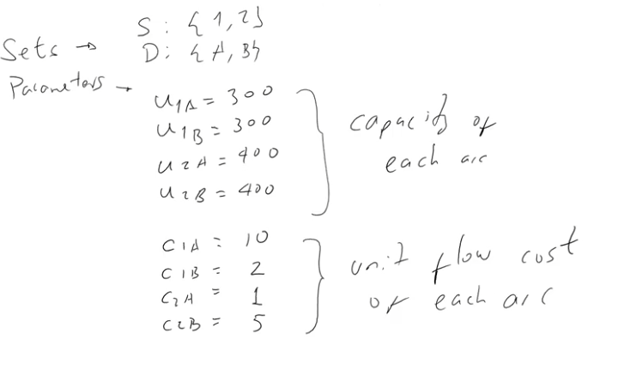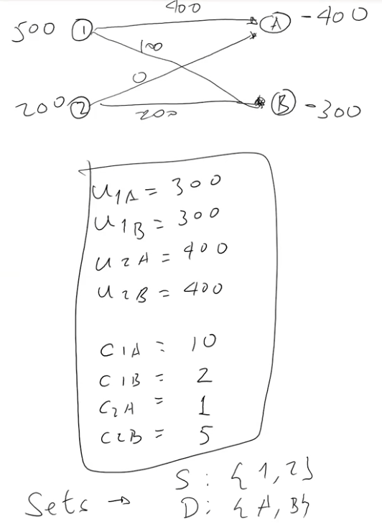

**CAPACITY CONSTRANT (U)**



**COST (C)**

**(OF NODES)**



**FLOW OF GOODS**

**DEMAND**

**SUPPLY**

***(Parameters Continued)***

**DEMAND / SUPPLY of each node**

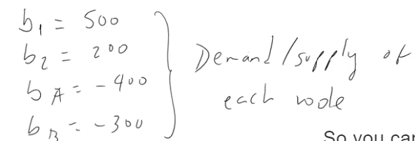

**VARIABLES**

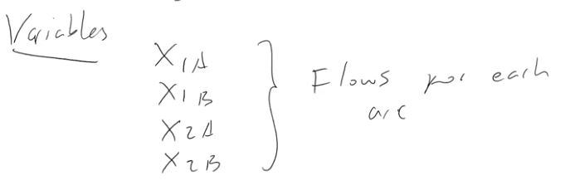

**OBJECTIVE FUNCTION**

**Goal: minimize the cost of each arc**

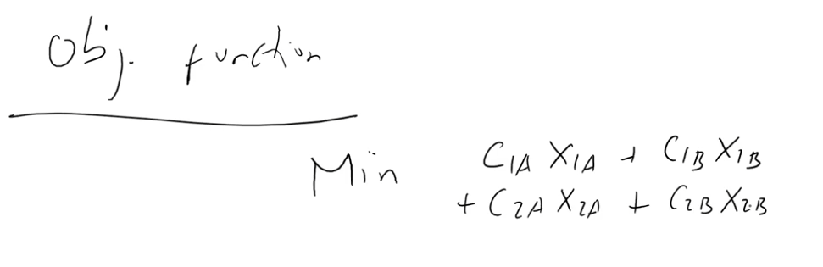



**COST (C)**

**FLOW OF ARC**

**CONSTRAINTS**

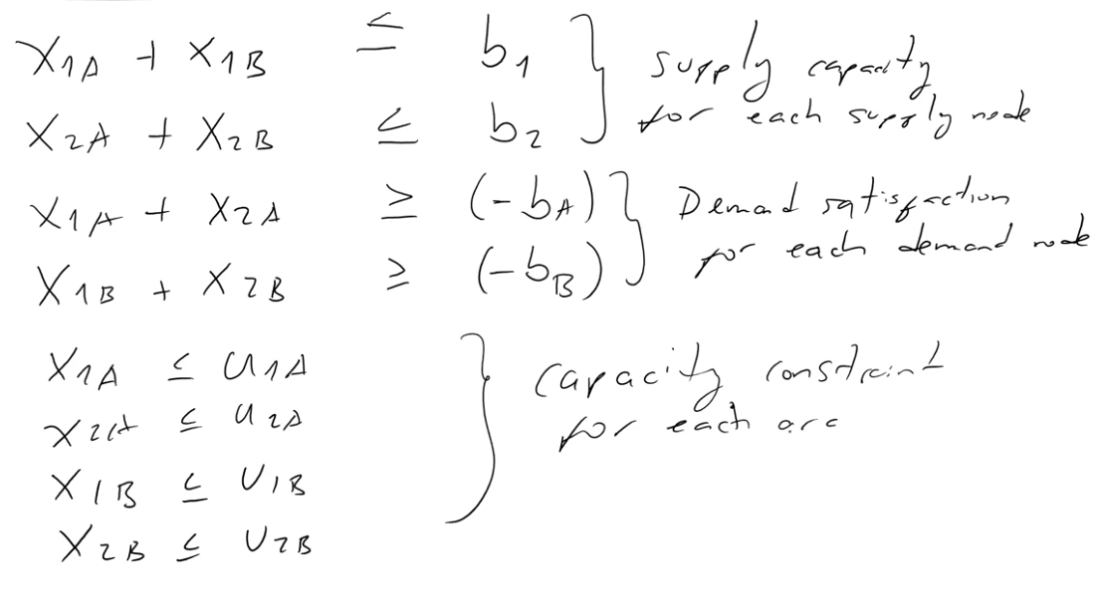





**SETUP FOR *>> GENERAL <<* TRANSPORTATION PROBLEM**

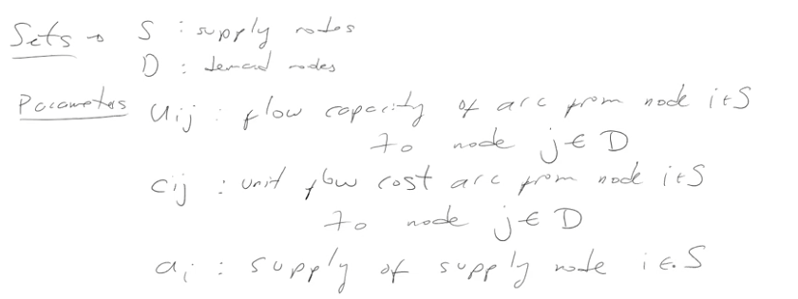

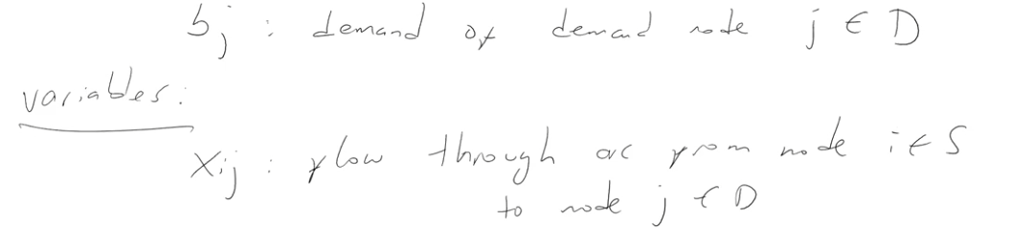

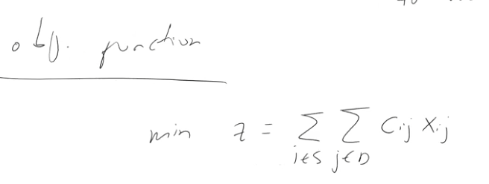



**COST (C)**

**FLOW OF ARC**

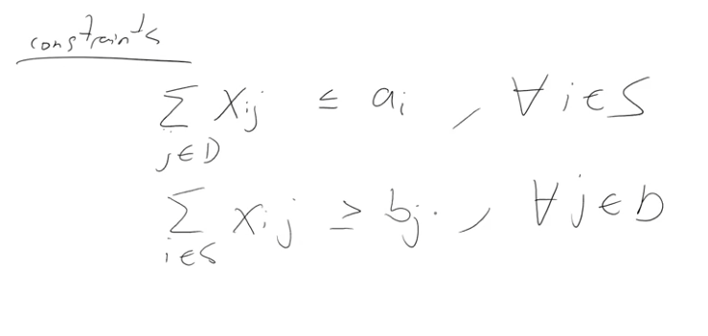

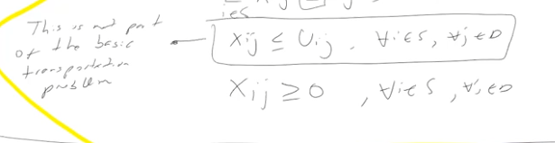

**SET MAX CAPACITY OF NODE**

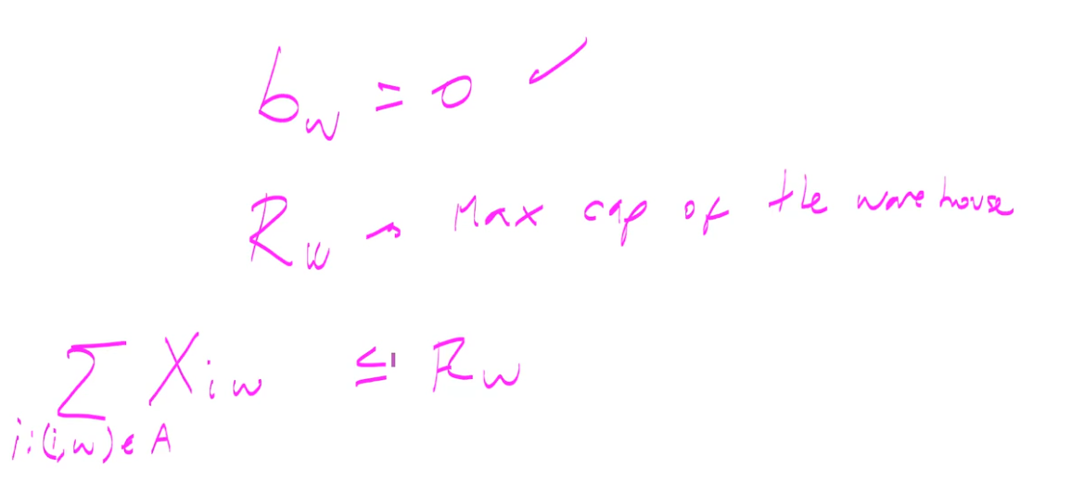

**The number of units must be less than the capacity**

**Transshipment node = 0**

**Changing units in network problem**

Simply multiply the conversion unit by the number of units within ***Xi, j***

**Unmet Demand (Supply < Demand)**

* Add a slack variable (- for too little supply), (+ for too much supply)

**General setup for unmet demand or supply**

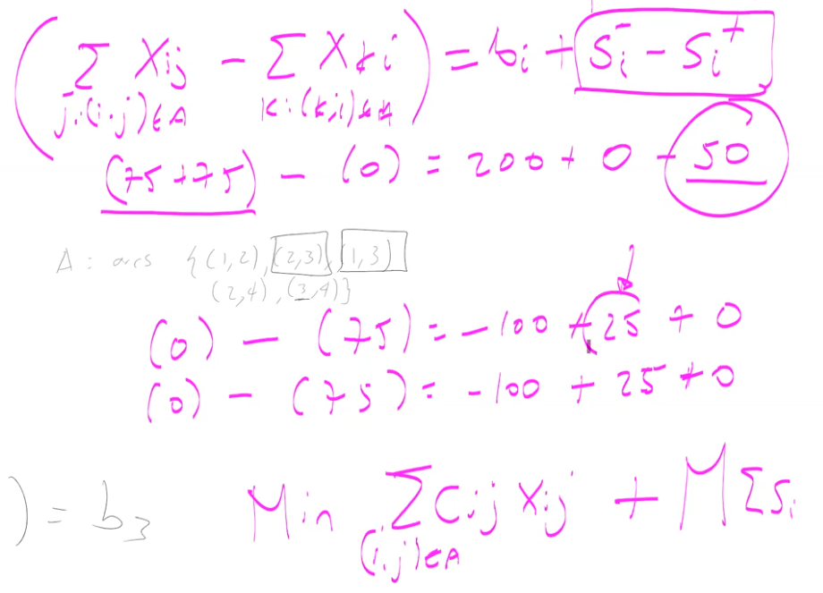

**Changes to the Objective (+ M ∑[Si]**